- Problem analysis
The aim of this project is to build a route-finding system that can identify the shortest possible route between two locations chosen by the user. “optimal” means the path with the lowest total travel cost, where each cost represents the estimated time needed to travel between two connected locations. The map I designed contains a set of locations (nodes) connected by roads (edges), each with its own travel time. The main twist is a set of intentional cycles. The clearest example is nodes A and D, which connect to each other in both directions. Without a visited-node mechanism a search would bounce between them indefinitely, so the closed set in A* is essential for correctness, not just efficiency. All roads are two-way and the environment is fully known from the start. The environment is observable, deterministic, and static: nothing changes during the search, and the same input will always produce the same output. The nodes have coordinates, which give the map a spatial structure and allows the system to use a heuristic to guide the search efficiently.

- Justification of approach
For this project I chose to use the A* search algorithm because it is well-suited to finding the shortest route on a weighted map. A* combines the cost of reaching a node with a heuristic estimate of the remaining distance, which allows it to focus the search on the goal without exploring the entire graph. Since each location in my map has coordinates, I can use Euclidean distance as the heuristic. This value never overestimates the true remaining cost, which makes it admissible and ensures that A* will always return the shortest possible route. A* is also efficient for this type of problem because it avoids unnecessary exploration and handles loops safely by keeping a closed list of visited nodes.
Dijkstra's algorithm also finds the shortest path but explores far more nodes without a heuristic, which is inefficient on a graph with cycles like mine. Depth First Search is unsuitable as it can loop indefinitely in cyclic graphs and gives no optimality guarantee. For these reasons, A* provides the best balance of optimality and efficiency for my map design.

- System representation
The system is represented as a weighted graph where each node corresponds to a location, and each edge represents a road with an associated travel time cost. The map includes intentional cycles as the twist. The A-D loop is the most direct example: both nodes list each other as neighbours, so the closed set is what prevents infinite re-expansion. A state is defined as the agent’s current node, and actions involve moving along any connected edge. Transition costs are taken directly from the edge weights. Internally, the graph is stored as an adjacency dictionary, while a separate coordinate dictionary supports the Euclidean heuristic used during search.
In A*, each node is evaluated using the function:
f(n) = g(n) + h(n)
g(n) is the accumulated cost from the start node to n.
h(n) is the heuristic estimate of the remaining distance to the goal (calculated using Euclidean distance).
f(n) is the combined score used to decide which node to explore next.
This structure allows the agent to prioritise promising routes while avoiding unnecessary revisits to nodes involved in loops.
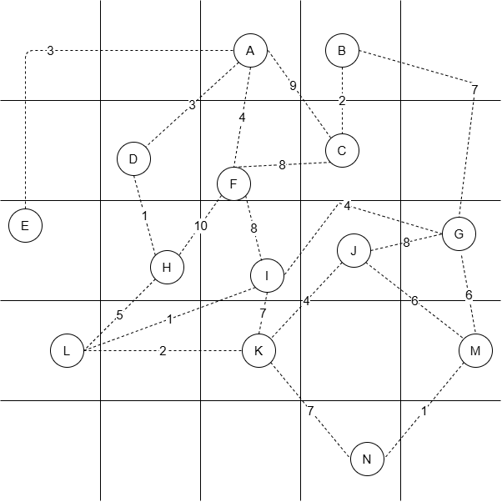

- Algorithmic plan

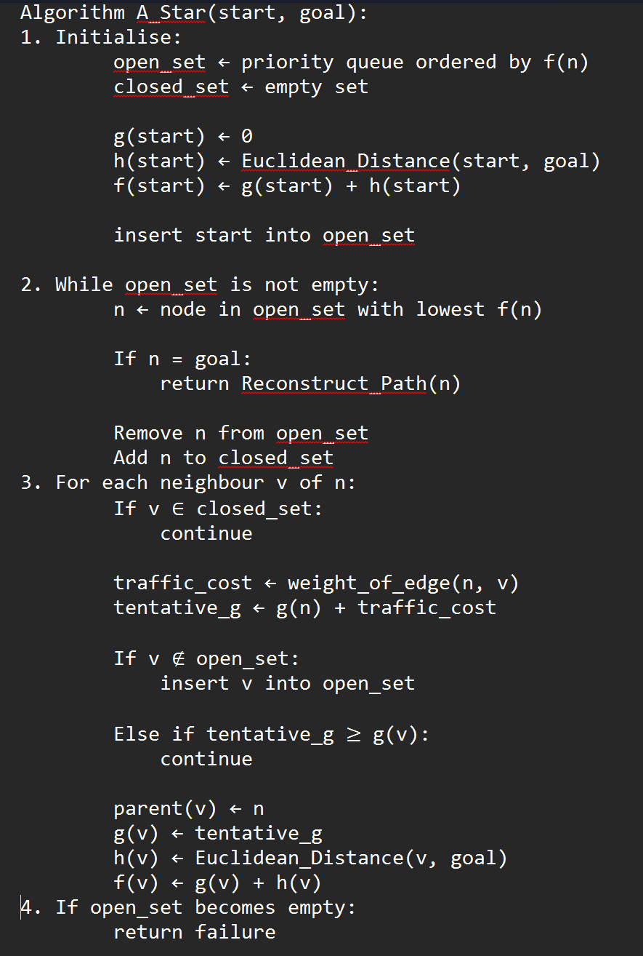
Component 2: Implementation

This is the link to my code repository
https://colab.research.google.com/drive/1D8E2xIUP54cNhcE2a8WSBP3BGeXmfIbp?usp=sharing

Component 3
Advanced AI Contrast
Modern deep learning systems approach route-finding in a fundamentally different way from my foundational A* implementation. Instead of explicitly searching through a graph, a neural model would learn patterns from large datasets of historical routes, traffic conditions, and user behaviour. This gives it capabilities that extend beyond what a rule-based system can achieve.

Capabilities and Efficiency

A deep learning system could adapt to real-time changes, predict traffic conditions, personalise routes based on user preferences, and generalise from incomplete or noisy data. These strengths come from its ability to learn statistical patterns rather than rely on fully defined graphs. My A* system operates in a static environment and cannot update its behaviour without manual changes to the graph. A* is optimal on a well-defined map but cannot anticipate future conditions or learn from past searches.
Transparency and Explainability
A key difference lies in explainability. My system is fully transparent: every decision is based on explicit g(n), h(n), and f(n) calculations, and the reasoning path can be reconstructed and traced. However deep learning systems, often behave as black boxes, where internal representations are difficult to interpret. This lack of transparency raises concerns about trust, and the ability to audit is limited.

Potential Unintended Consequences

Deep learning systems may behave unpredictably in rare or unseen scenarios, especially if the training data does not include similar examples. They may also inherit biases from historical data, such as avoiding certain routes simply because they were historically congested, even when they are currently clear. My A* system avoids these issues because it relies solely on explicit rules and a fixed graph, but this simplicity also limits its flexibility.

Reflection on System Behaviour and Design Decisions
Implementing the A* algorithm gave me a clearer understanding of how my design decisions shaped the behaviour of the system. Seeing it run highlighted things I had not fully considered. The A-D cycle in the graph, where both nodes connect to each other, showed me that the closed set is not just a performance optimisation but a correctness requirement: without it the algorithm would loop between A and D indefinitely.
Adding input validation was also unexpected but necessary to prevent crashes on invalid node entries. Overall testing and implementation helped me recognise the internal strengths and limitations of A*.

Evaluating A in Practise
Testing the system across multiple scenarios demonstrated the strengths of A* as a functioning algorithm rather than just a conceptual design. The most striking behaviour was its consistency: the algorithm always returned the same optimal path for identical inputs, reinforcing its deterministic nature. This made debugging straightforward and increased confidence in the system’s reliability.

The Euclidean heuristic performed well, guiding the search efficiently without overestimating remaining costs. Small changes in node placement or edge weights can significantly influence the search order, which deepened my understanding of heuristic driven search.

Limitations
The limitations of my implementation became clear during testing
- Static environment: The system cannot adapt dynamically to changing conditions. If the weights of the nodes begun to change after run time it may cause the system to break or get more inefficient solutions.
- No learning: It does not improve in efficiency, search time or any other metrics based on past searches or user behaviour
- Heuristic Dependant: If there were errors in how the graph was plotted or for Very large scale maps the heuristic could negatively influence the path.
- Cycle reliance on closed set: the algorithm's safety in cyclic graphs depends entirely on the closed set being correctly maintained. A bug here would cause infinite loops on most real-world graphs.
These limitations largely differ to that of modern AI systems which can learn and adapt.

Ethical Reflection and Trade-offs

Transparency and Accountability
My system is fully transparent: every decision can be traced to explicit rules. This makes accountability straightforward, as errors can be directly linked to specific calculations or graph definitions. Deep learning systems lack this clarity, making it difficult to determine responsibility when something goes wrong.

Predictability and Safety
A* predictable and safe because it always returns the optimal path given by the data. Deep learning systems may behave unpredictably in rare situations, especially if the training data lacks similar examples. This could lead to ineffective or inefficient routes.

Privacy

A* requires no personal data. It operates solely on the graph provided. A deep learning system, however, may rely on sensitive location data or user histories, raising concerns about consent, data storage, and potential misuse. These issues align with broader debates around data ethics and privacy in AI systems.

Bias and Fairness

A* treats all nodes equally because it’s based on rules. However deep learning model could develop biases from its training data, such as consistently avoiding certain routes due to historical patterns. These biases may be invisible and difficult to correct due to the system’s lack of transparency.

Trust and over-reliance
Users may trust the deep-learning system too much making them susceptible to believing the mistakes that system makes sense they do not verify the path themselves. My system avoids this due to it being simpler, traceable and transparent.

Scalability of harm
My system is designed to search in fully formed graphs where there is very little noise, and the graph needs to be fully completed. An error in my system affects one user on one query. The same mistake in a deep learning system deployed at scale could mislead millions simultaneously.

Data dependency
My system is not data dependant but only requires a clearly defined graph. Whereas a deep learning model would need training data to work efficiently and may learn bias from its data, it could avoid some routes based on history of traffic despite the road currently being free.

Regulation and governance
My system is very easy to audit and regulate because it is rule based and we would just need to check if any of the operations go against any rules. Deep learning systems are harder to regulate due to their complexity and lack of transparency. This would make the system harder to be governed.

Conclusion
Reflecting on this project has shown that simpler rule-based algorithms remain valuable for their transparency and reliability. However modern deep learning systems provide greater flexibility and real-world solution, but they introduce ethical challenges related to privacy, bias and accountability. Understanding these two sides and their weaknesses is essential when deciding which type of system is more suitable for the problem. More flexibility and capabilities don’t automatically result in safer outcomes but sometimes simpler systems like mine may be more trustworthy and a good enough solution to the problem.

